***Experiment 6***

**Aim:** Streaming Analytics with Kafka and Spark: Set up a data streaming pipeline using Apache Kafka to ingest real-time data and process it using Apache Spark Streaming for real-time analytics.

***Starting Services:***

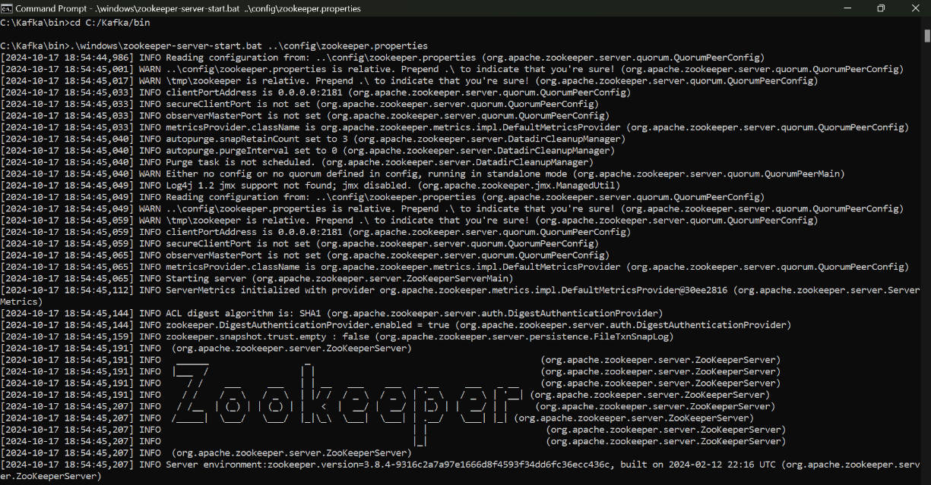

***Fig 1: Zookeeper Server***

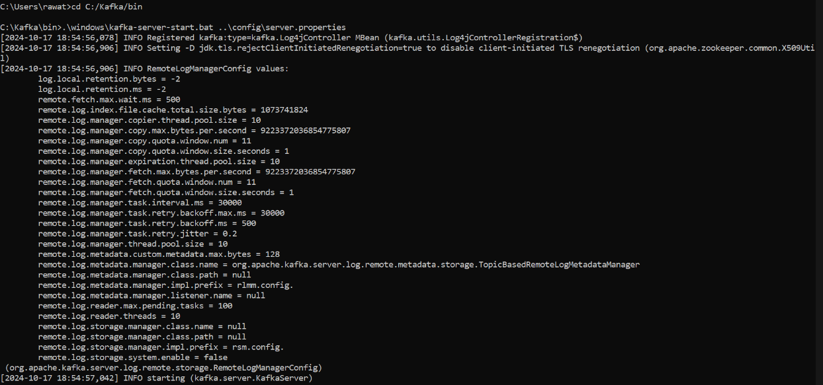

***Fig 2: Kafka Server/Broker***

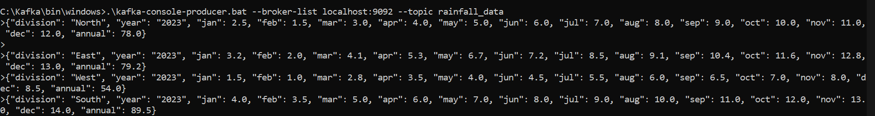***Fig 3: Sending Data to Kafka Streaming using Dictionary line by line***



***Fig 4: Sending Data to Kafka Streaming using CSV File***

***Spark Code Execution:***

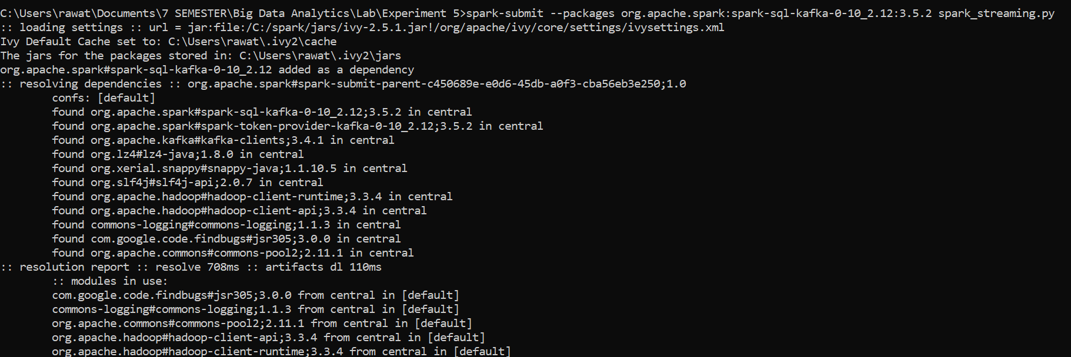

***Fig 5: Execution of Spark File/Code***

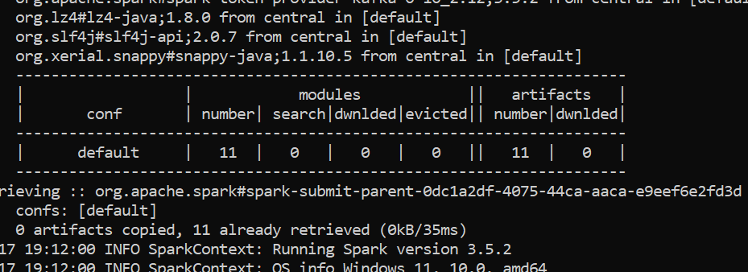

***Fig 6: Output of Execution of Spark File/Code showing installation of all required modules***

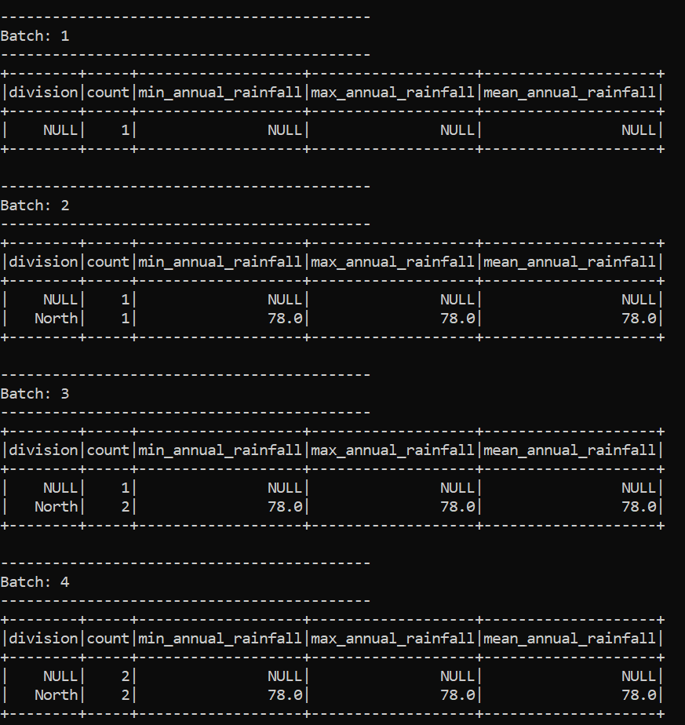

***Fig 7: Batch Execution of Spark Code showing batch 1-4***

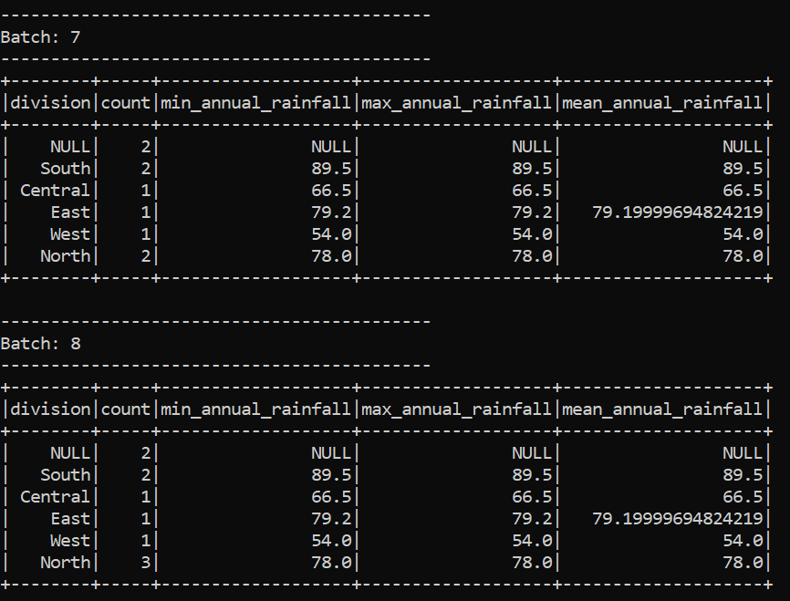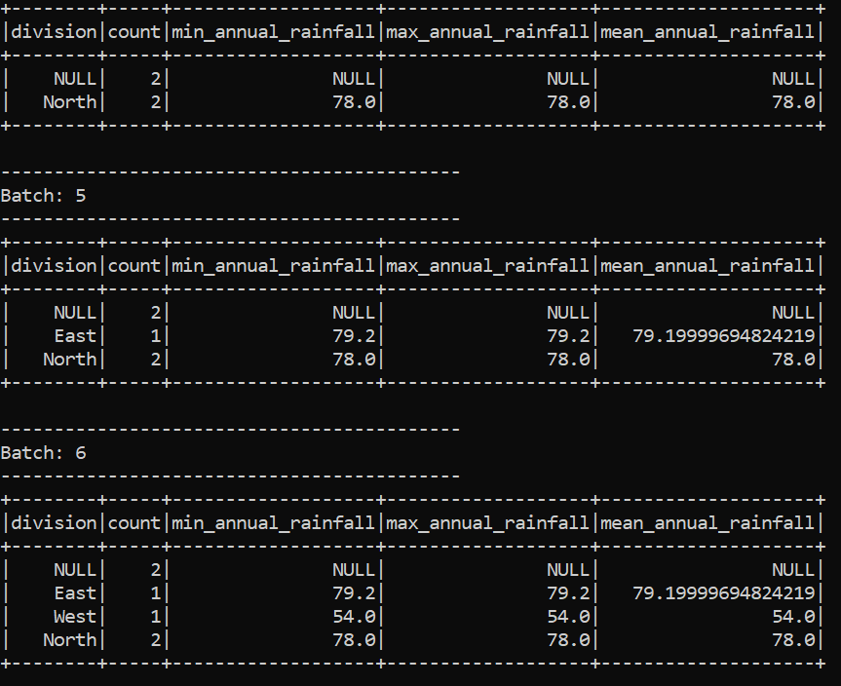***-8***

***Fig 9: Batch Execution of Spark Code showing batch 7-8***

***Fig 8: Batch Execution of Spark Code showing batch 5-6***

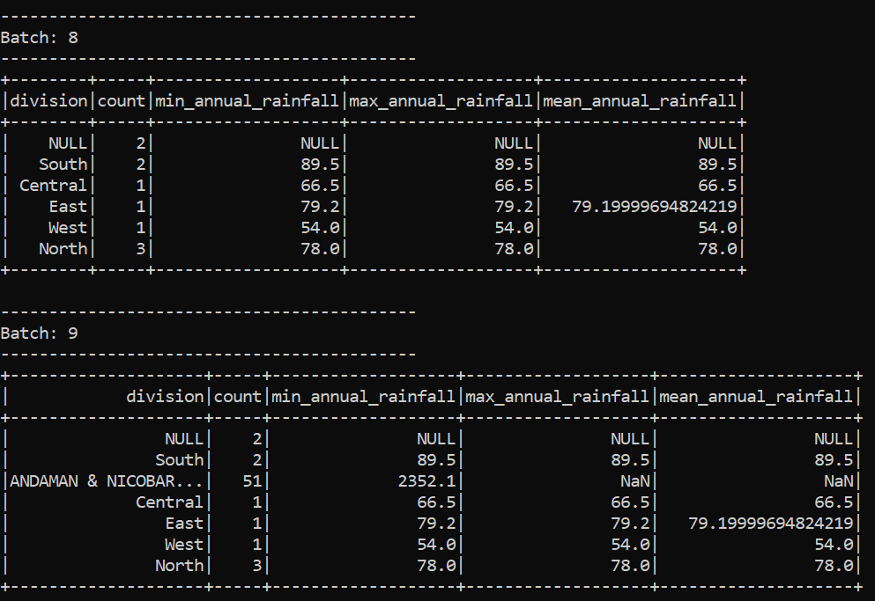

***Fig 10: Batch Execution of Spark Code showing batch 8-9***

***Fig 11: Batch Execution of Spark Code showing batch 10***

